**Instagram User Analytics**

**Project Description**

This project helps with the analysis of raw data into relevant insights. This project is more about analyzing data by using SQL queries by answering various business requirement questions.

**Project Approach**

Firstly, SQL queries were executed to create tables and stored the given raw data into them. Then essential data was retrieved by executing various SQL queries.

**Tech Stack used**

Dbfiddle.com MySQL v8 was used while execution of commands.

**Solution**

1. Select * from users order by created_at ASC limit 5;

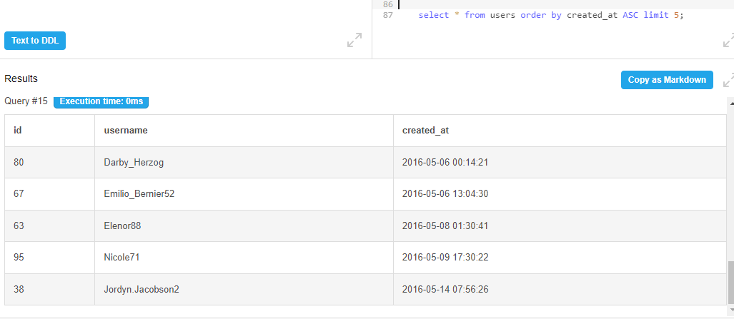

**User 80, 67, 63, 95 and 38 are the oldest users of Instagram.**

1. Select * from users left join photos on users.id = photos.user_id where photo.id is NULL;

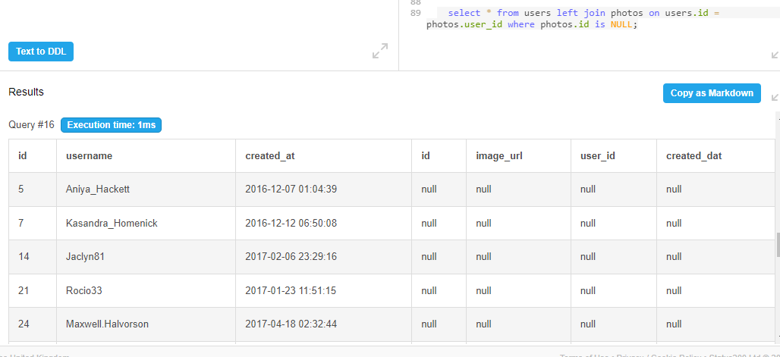

**These are the users who haven’t posted a single picture.**

1. select photos.image_url,photos.user_id,photos.id, count(*) as TotalLikes from likes inner join photos on likes.photo_id=photos.id inner join users on photos.user_id= users.id group by photos.id order by TotalLikes desc limit 1;

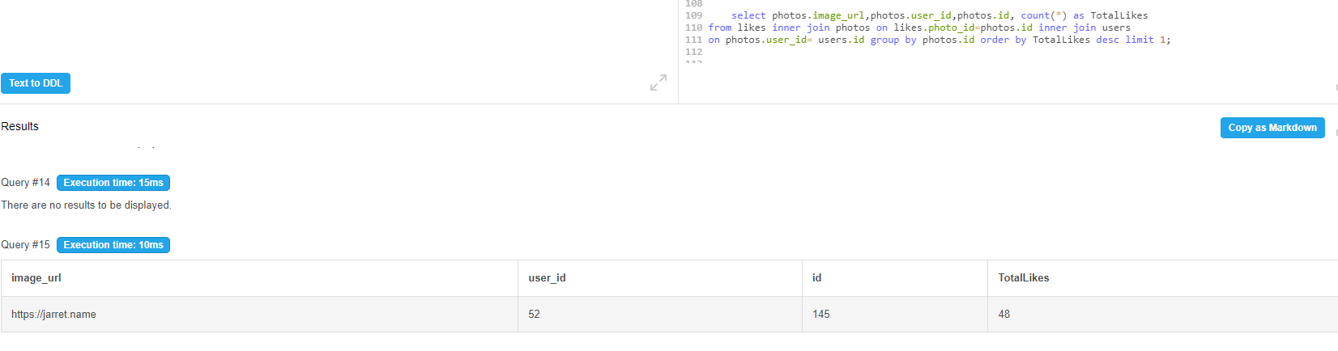

**The winner of the contest is user 145 having most likes.**

1. select tags.tag_name, count(photo_tags.tag_id) as count from photo_tags inner join tags on

photo_tags.tag_id = tags.id group by tags.tag_name order by count desc limit 5;

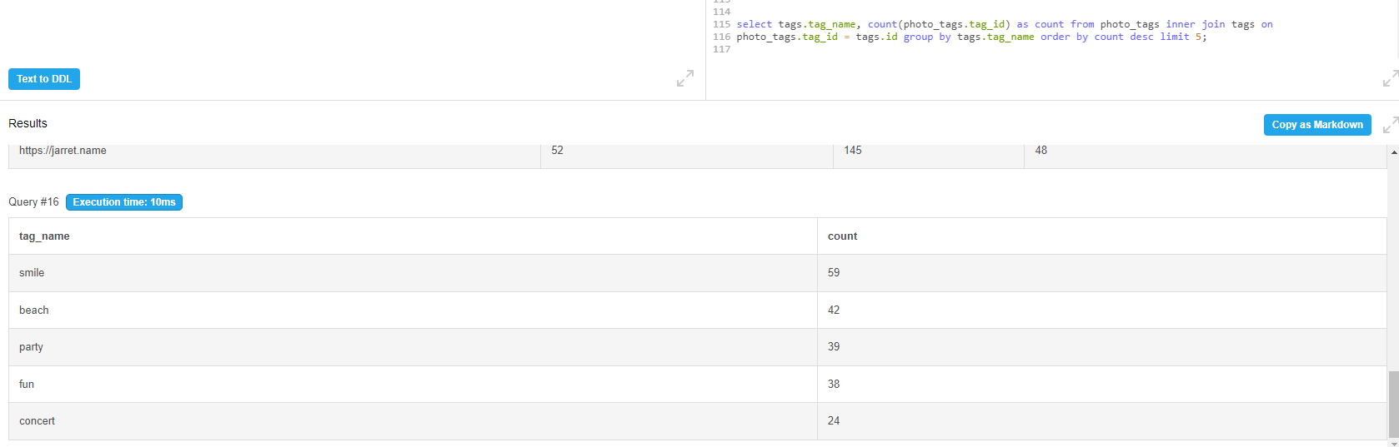

**The tags smile, beach, party, fun and concert are most commonly used tags.**

1. select count(created_at) as count, dayname(created_at) as Popular_Day from users

group by Popular_Day order by count desc limit 2;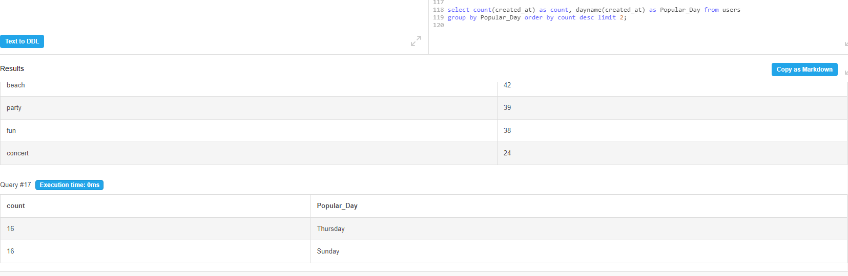

**Users mostly register on Thursdays and Sundays.**

**Investor Metrics**

1. select (select count(*) as Posts from photos)/(select count(*) from users) as Average_Posts;

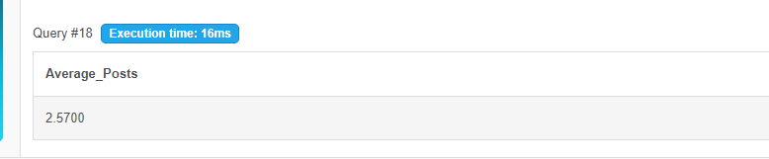

1. select users.id,users.username, count(likes.user_id) as counts from users inner join likes on users.id = likes.user_id group by likes.user_id having counts = (select count(user_id) from photos);

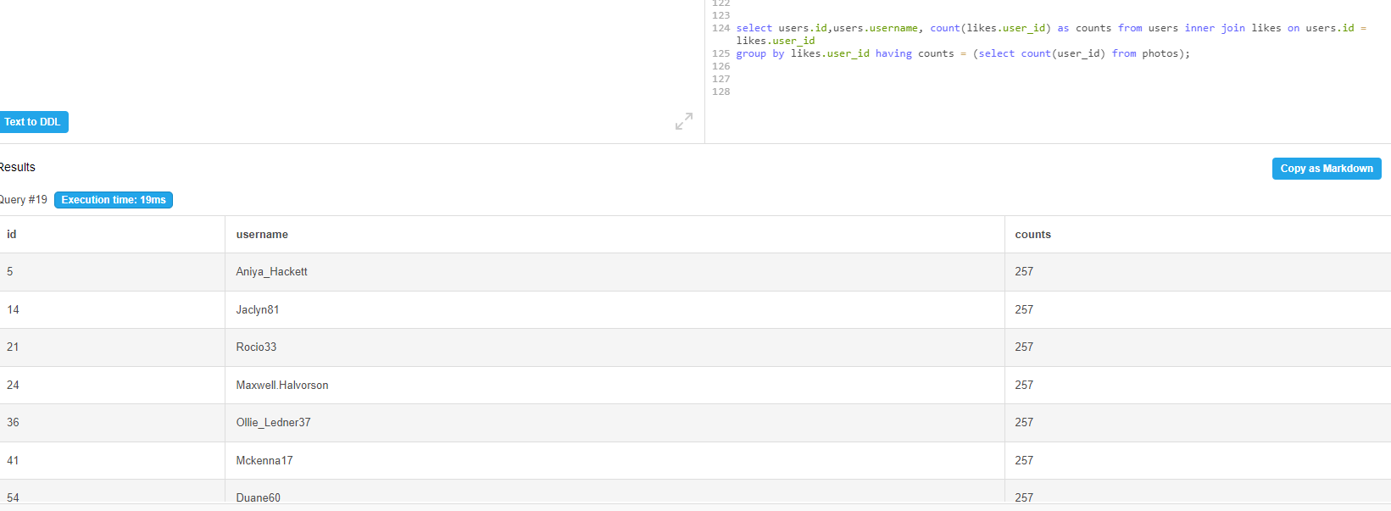

**Insights & Result**

This project helped me in learning new functions and analyzing data using MySQL. I learnt about how analysis process can help any business in productivity and development.